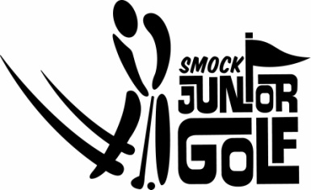

2020 Smock Junior Golf Camp
Instructor: Bill E. Smith

Instruction will include: Full Swing, Pitching, Chipping and Putting

Camp Includes: Daily Refreshments, Prizes, Camp Tee-shirt, Pizza party on Friday

For more information:
Smockgolf.com Campers will receive
Smock Pro Shop 317-888-0036 a full refund due to
Smock Driving Range 317-888-4863 any state mandates!!!

Session | Date | Age Group  (circle age of participant) | Time  (based on age group)
1 | July 13-17 | 5-8  9-12  13+ | 8:00am – 9:15 am  9:45am – 11:00 am  11:30am – 12:45 pm
N/A | N/A | N/A | N/A
2020 Smock Junior Camp will be held at:
Smock Driving Range
4225 Todd Rd. Director of Golf: Ken Washam ken@smockgolf.com
Indianapolis, IN 46237 Teaching Professional: Bill E. Smith billsmith57@att.net

